EEE 120

Honors Lab Answer Sheet
Name: Dylan Shah
Instructor/Time: Dr. Steve Millman Tu Th 3:00 PM - 4:15 PM Date: March 26, 2026

Task H-1: Add the JUMP Instruction
The updated program counter:
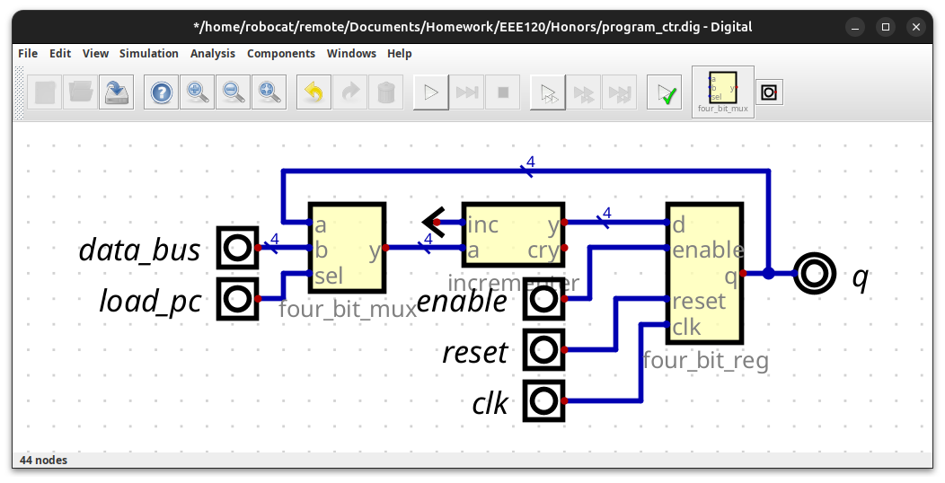
Updated Adder_gen:
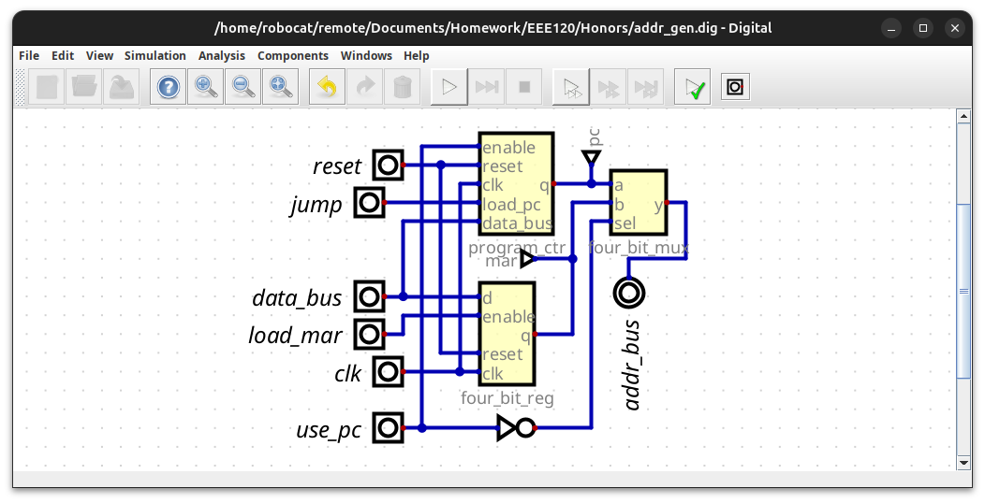
Updated Microprocesser:
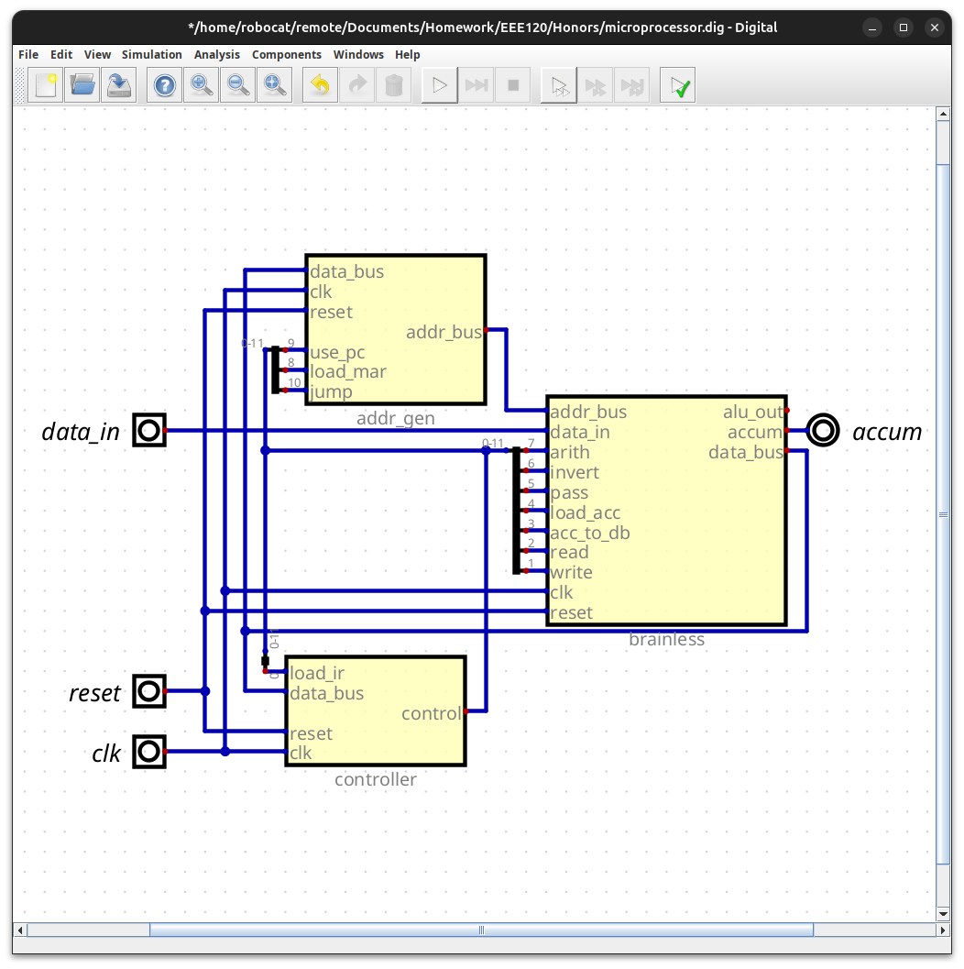
Updated ROM:
... old rom
1205 # Jump
0604 # Set the PC to input + 1
0000
0001

RAM:
4 // Do something
0 // Load ACC
3
4 // Zero
8 // Jump
0 // to load
2 // Stop
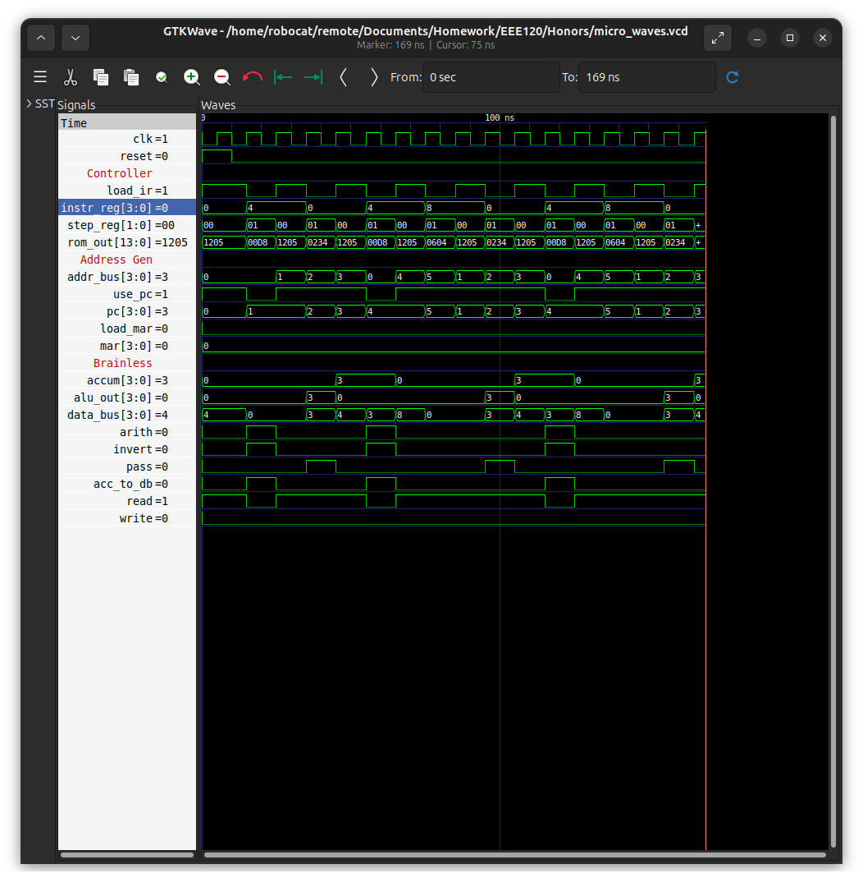
Challenges I faced:
I was setting the MAR insted of the PC with the microcode at first, it took me a while to see the issue as you can not see inside of components in Digital.

H2: Add the BRANCH ON ZERO Instruction
Updated Brainless:
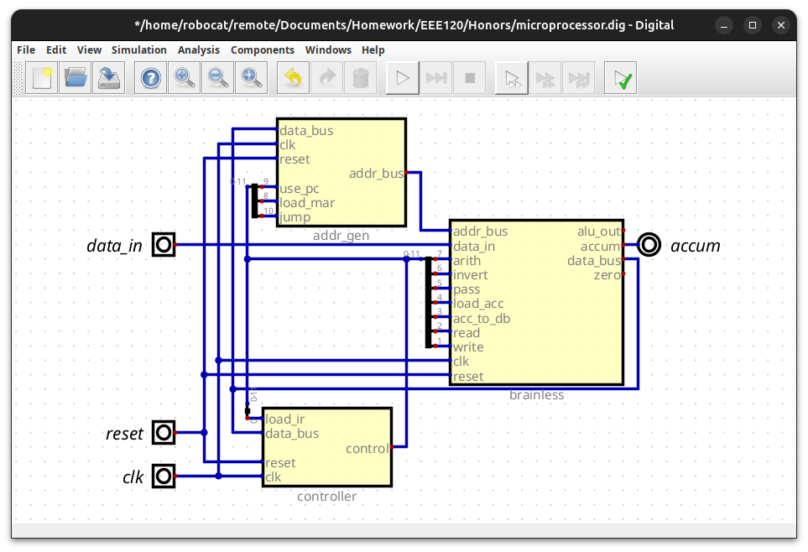
Updated Adder_gen:
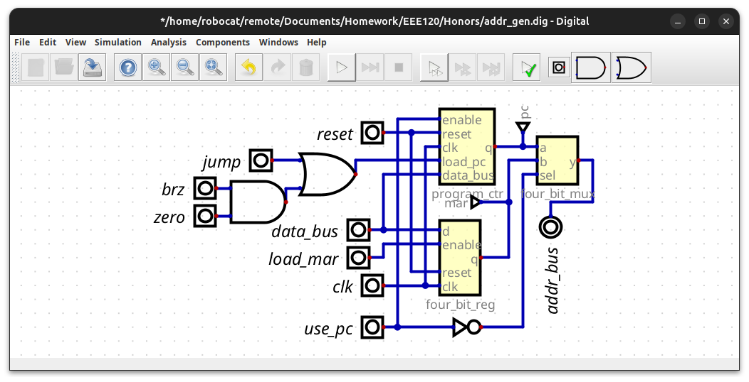Updated Microprocesser:
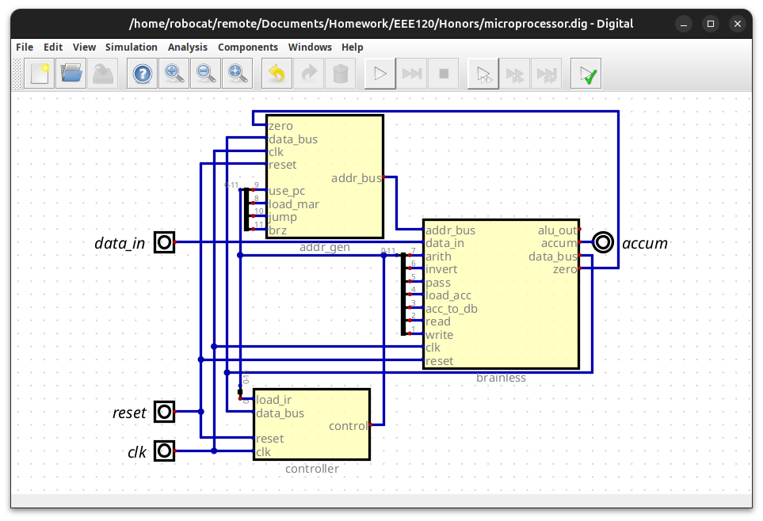
Updated ROM:
...
1205 # Jump if zero
0A04
0000
0000
RAM: (One with loading Data In)
7 // Load ACC with Data In
5 // Subtract one
1
9 // Break loop if zero
6
8 // Jump to the subtract
0
2 // Stop

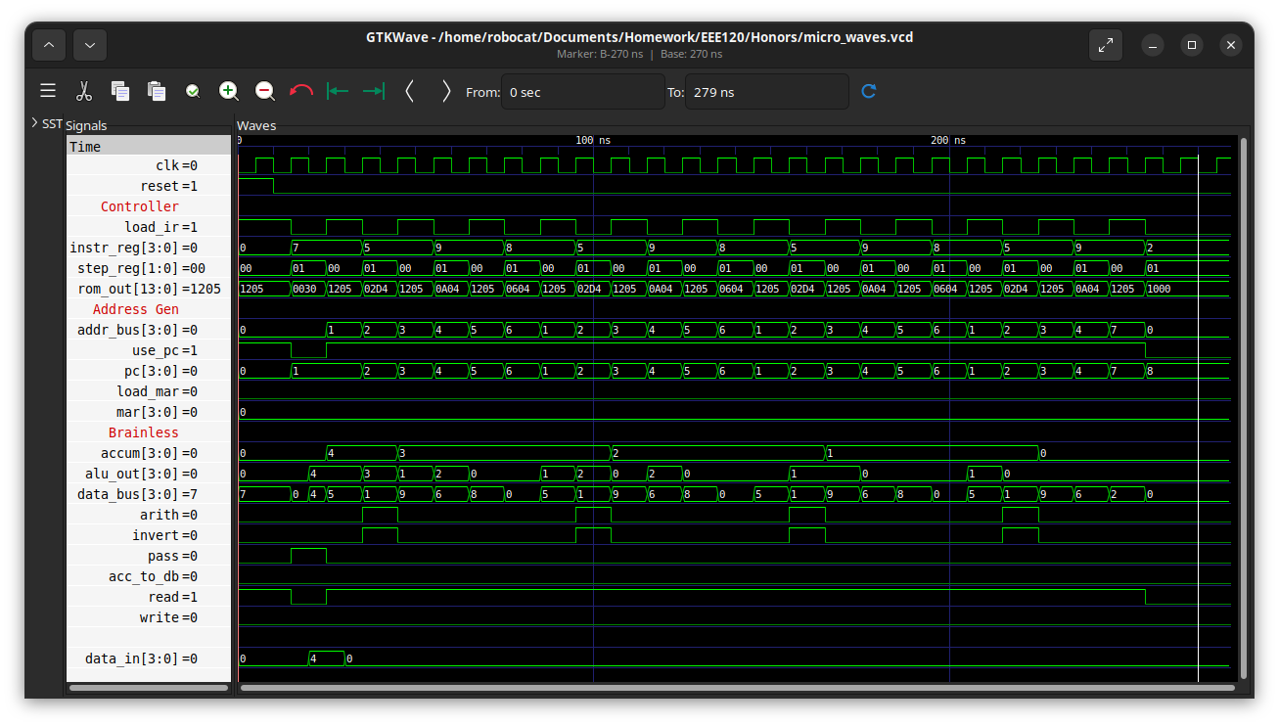
RAM (Given):
0x0 # Load ACC
0x1 # a nonzero value
0x9 # BRZ instruction
0x9 # not taken since accum is not 0
0x0 # LOAD ACC
0x0 # zero!
0x9 # BRZ instruction
0x9 # branch to address 0xA
0x0 # Load ACC
0x5 # this should be skipped!
0x2 # STOP
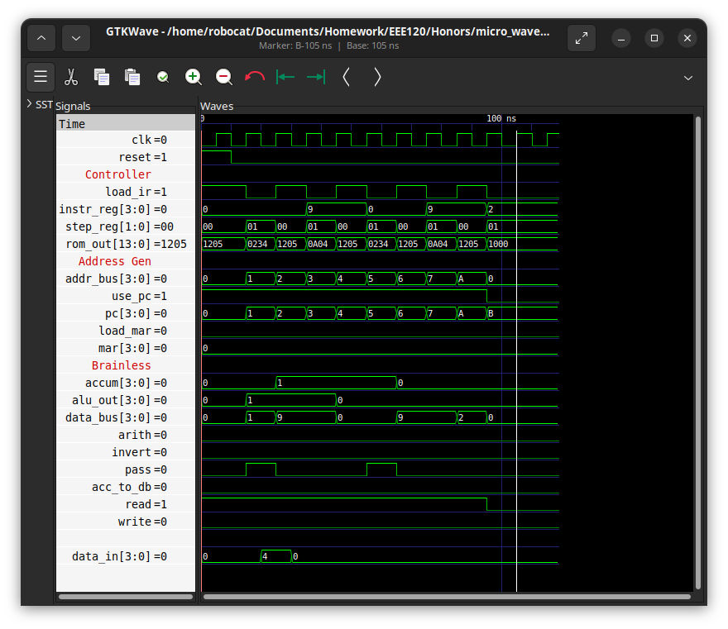
Challlenges I faced:
Somehow, in the rom, the setting to preload at start was sleected and it was loading my values from Lab 4. IDK how this happneed or why the previous one worked, but that was fun to debug.

H-3: Build the Seven-Segment Display Translator

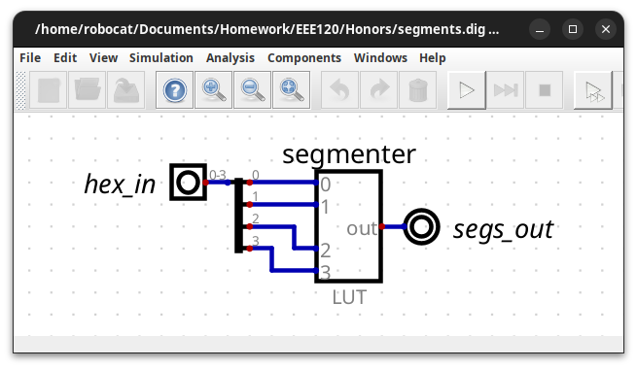
H-4: Bring the Instruction Register to the Top

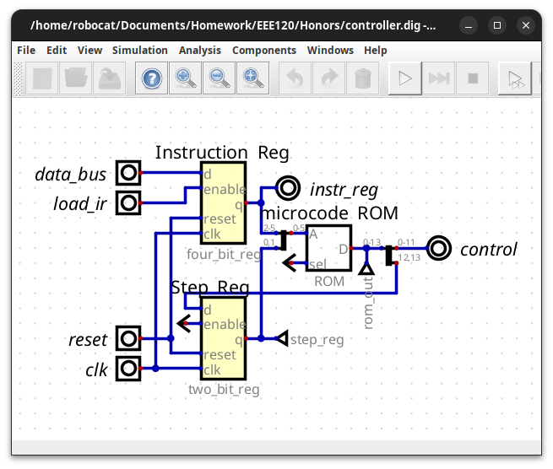 H-5: Invert the Reset

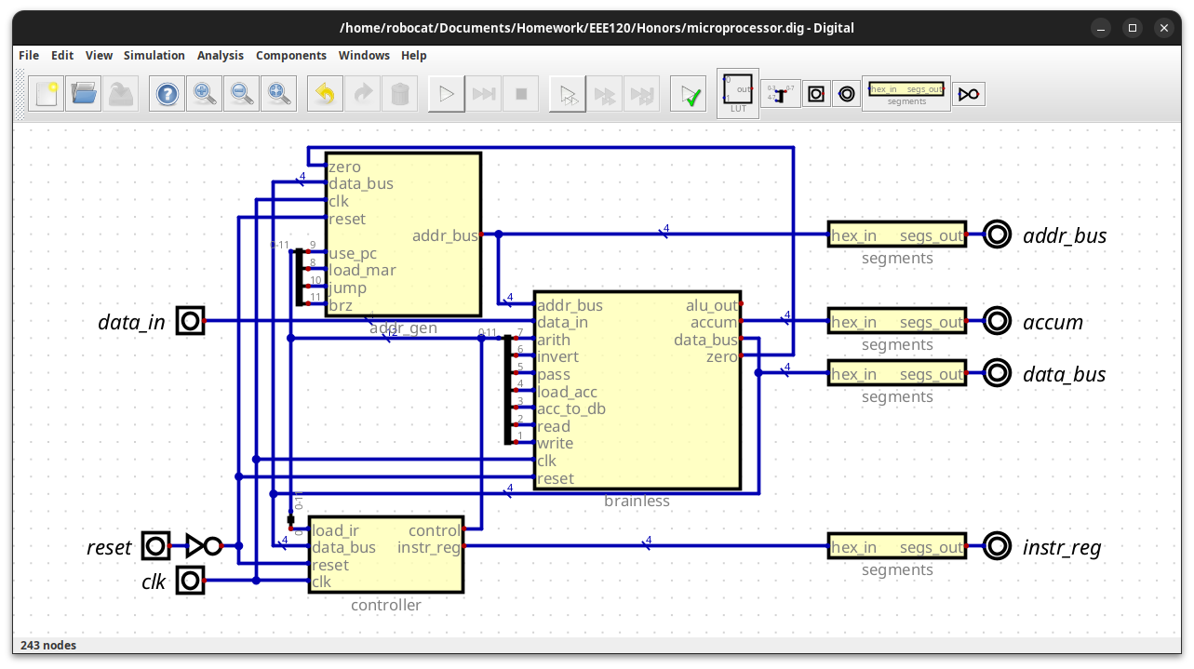
H-6: Connect the Remaining Segments Instances and Assign Pins

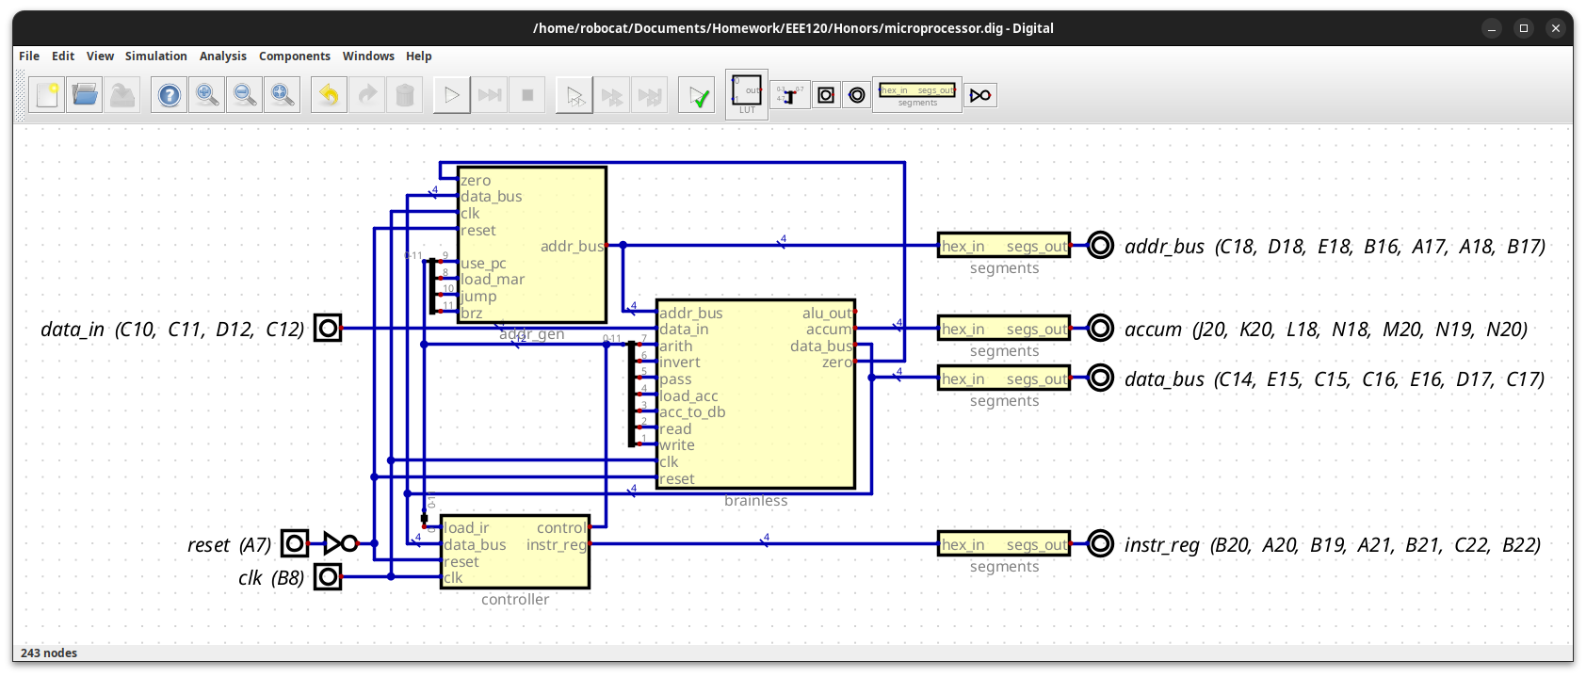
Task H-9: Run on the Board
Issues I had:
At first, the TA at the lab directed me to use one of the Rocky Linux computers in the lab. Unfortunaltly, I do not have a login to those machines, nor do they allow flashing the FPGA used for the lab. Afterwards, I moved to the Windows PC, but the ethernet cable to that one did not work. This ment that there was no connection for Windows to establish a network user, so I had to move to a third computer. After that, everything worked perfectly.

H-10: Create a video and submit your report
https://drive.google.com/file/d/1Mq8Fvji5U2NXOfNO6KChJpb_qwtqVkXq/view?usp=drive_link

